Digital Business Brochure 2021 Edition.

The Better Than A1 Newer Bigger More Promising Business Opportunities Leader IAIN INNES Presents A Bigger Money Business Schematic. Invention, Film, Music & Literature Arts Portfolio.

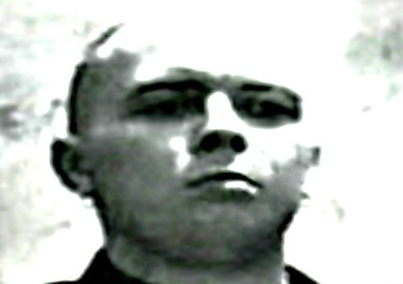 | Here’s the “number 1 business advert” you're impressed with. This is the “number one world portfolio” you're interested in. The business is displayed new, plus on merit it is all position 1ST via the leader.  The better Intellectual Property biz opportunities are only available to buy as a Complete. Business Package A. Plus Business Package B… Invention Concepts/Film Scripts/Books/And Music Lyrics might become available in sets of 10, 25, 50, 100…  Only the most serious bigger money deals will go down here.  These are the very best Blueprints to success.  Yours Naturally + Sincerely Iain Innes. Contact Today. | 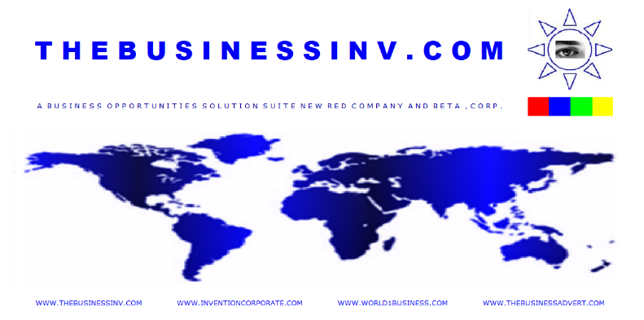

Welcome To The Intellectual Property Bank. The 1444+ Piece Better Viable Portfolio Suite. The 1st Positioned Online Global SERPs “Number 1 World Business” 5+ Years Running…

FIRST POSITION WWW. BUSINESS PROMOTIONS:

The Business Arts.
“With Great Care And Attention Bigger Global Banking Business Entrepreneurs My Site Holds 1414+ Business Concept/Invention Strategies That Can Make You Much Richer Wealthier Read View And Chew Over All Upfront, Invest Bank And Calculate Pact In Depth With The Concept Leading Edge Winning Entrepreneurship Hefty Mega Talented Business Schematic… Part Of The Magic.”

The 1st Act Of Invention.
"With My Colossal Visible Online 1ST Placed “World Business Advert” … “The Number One Business Advert” … “Number 1 World Business” … “Number 1 Business Portfolio” Innovation And Invention More Viable Intellectual Property Machine… Made Men Can Win A Bigger Money Business Play Plus Completely Flatten The Competition."

What I Offer:
- New And Complete Other Business Networks/Protected Intellectual Property Concepts.
- Unique Content Marketing, SEO Advertising Visibility Viability + Bigger Money Portfolio Business Drive.

- Ability To Innovate And Invent Machine Further System More Better Unique Business Opportunities For The Alchemical Engine Here Is An Added Vast Many More Viable Money Banking Vault Key.

The Company Blueprint:
- A 1400+ Piece Business Inventory Opportunity Suite Split Generously Into Two Portfolio’ The Complete. Business Package A) Is For Sale + Portfolio B) Beta Blueprints Might Become Available.
- The Intellectual Property Consists Of 1414+ Business Invention Concepts… 12+ Movie Scripts, 150+… Song Lyrics Numbers, 68 E/Book Literature Arts Compendium Designed For The Film Industry And More.

Non Disclosure Agreement

Disclosure Agreement Parties.

This Non Disclosure Agreement Invitation and Brochure (To view The Connecting Company Invention I.P. Invention Opportunity' + Film Book And Music Intellectual Property Portfolio Suite/'The Business Blueprints') is entered into by Iain Innes the Owner and Yourself the Reader. Iain Innes and Yourself/Business Person or Company to whom you will disclose my information for the purpose of making money plus preventing the unauthorized disclosure of Confidential Information (as defined below unless it makes Iain Innes MONEY.)

Disclosing party may disclose confidential and proprietary trade secret information to whoever he wishes to. The receiving party cannot steal these Intellectual Properties in any way. The interested parties mutually agree to enter into a confidential relationship. If a court finds any breach of my terms in this Agreement invalid or unenforceable as applied to any circumstance, the remainder of this Agreement shall be interpreted so as best to affect the intent of the parties.

This Agreement shall be governed by and interpreted in accordance with the laws of the United Kingdom. Any controversy or claim arising out of or relating to this Agreement, or the breach of this Agreement, shall be settled by arbitration in accordance with the rules of the United Kingdom and judgment upon the award rendered by the arbitrator(s) may be entered in any court having jurisdiction. The prevailing party shall have the right to collect from the other party its reasonable costs and attorney's fees incurred in enforcing this agreement. Any such arbitration hearing shall include a written transcript of the proceedings and a written explanation for any final determination. This Agreement expresses the complete understanding of the parties with respect to the subject matter and supersedes all prior proposals, agreements, representations and understandings. This Agreement and each party's obligations shall be binding on the representatives, assigns and successors of such party.

+ Important Notice.

I, Iain Innes do declare that I have Invented all here today. I own all the Intellectual Properties/advances in the Technology/Inventions/Ideas displayed plus all Marketing material on site. Example. A Law passed in the House of Lords in 2002 United Kingdom supported by the Patent Agency stated that you can protect any form of Intellectual Property as long as its date of conception can be proven. So All Rights Reserved, thus Iain Innes owns all the Intellectual Property... Including but not limited to The Companies Invention Opportunities Portfolio' plus... All Innovations in Electronics Opportunities/Software Concepts/Web Marketing and Entertainment Book, Film and Music Literature within the Company... Plus the Company Brand WWW.INVENTIONCORPORATE.COM Business is Protected Intellectual Property. All Invention Alphabetic Text Word Combinations are further bound held within my Works of Copyrighted Literature plus added Intellectual Property Film Copyright... As you can see it is also in The Public Domain with plenty of witness' too. All The Intellectual Property/Business Opportunities display Onsite is a legit sound and safe Bigger Business League Investment opportunity. The Business Inventory here is Law Protected.

ALL INTELLECTUAL PROPERTIES PROTECTED + ALL DISPLAYED ON SITE IS COPYRIGHT/IP IAIN INNES: … 2008/2009/2010/2011/2012/2013/2014/2015/2016/2017/2018/2019/2020/2021...

The Globally Positioned First SERPs “World Business SEO” Presents... The Early 2021 Company Website Visual Video Tour. | THEBUSINESSADVERT.COM 100% New Business Content Marketing/SEO Film. An Effective Art Of The Superior Effective Online “Number 1 Business” Presence. | The Company’s Invention Portfolio Blueprint Schematics Movie. “Newest” September 2021 Additions.
 | 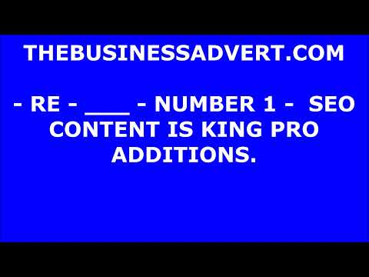 | 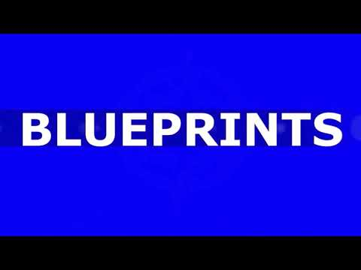

THE COMPANIES COMPLETED. BUSINESS DEAL IS AVAILABLE TO CAPITAL $££ DOWNLOAD TODAY AT THE INVENTIONCORPORATE.COM

THE COMPLETED. BUSINESS PORTFOLIO INTELLECTUAL PROPERTY PACKAGE IS FOR SALE.

IT CONSISTS OF “142” BIGGER MONEY INVENTION OPPORTUNITIES. THE COMPLETE. DEAL, INCLUDES 6X MOVIE SCRIPTS OF THE COMPANY. THE ORIGINAL COMPANY MUSIC LYRICS OPPORTUNITY DOCUMENT = 90 SONGS. PLUS, THE COMPANIES EXACT FORM AND METHOD ALCHEMY COMPENDIUM ARTS PIECE DESIGNED FOR THE MOVIE OPPORTUNITY… + THE "NUMBER 1 WORLD BUSINESS" 1ST SERPS POSITIONED LEADER ALSO HAS A BETA BUSINESS PORTFOLIO DEAL THAT I MIGHT MAKE AVAILABLE FOR SALE IN INTELLECTUAL PROPERTY SETS OF 10, 25, 50, 100… AT THE CORRECT BIGGER MONEY CALCULATION. YOU CAN VIEW ALL MY INTELLECTUAL PROPERTY NEW BUSINESS OPPORTUNITIES PORTFOLIO’ A. + B… IN COMPLETE TRANSPARENCY CHEW IT OVER HERE AT THEBUSINESSINV.COM BUSINESS DEAL A. THEBUSINESSINV.COM BETA BUSINESS SUITE LINK... NEW BETA BUSINESS SUITE POWERHOUSES 1144+ INVENTIONS/BUSINESS CONCEPTS AND MORE INTELLECTUAL PROPERTIES.

Contact Iain Innes Today: For The Business Deal:
Telephone United Kingdom On: +44 (0)1273 900055
Email: business@inventioncorporate.com
i.business@live.co.uk
WWW.THEBUSINESSINV.COM WWW.INVENTIONCORPORATE.COM WWW.WORLD1BUSINESS.COM WWW.THEBUSINESSADVERT.COM
The Intellectual Property Content Bound Herein Is Copyright/IP 2005/2021… IAIN INNES WWW.INVENTIONCORPORATE.COM

